1. Choose the app and feature
App: BookMyShow
New feature: Real-time Ticket Availability
The feature would allow users to see available seats for a movie or live event in real time and reserve a seat. During popular movie releases or major events, thousands of users may try to book seats simultaneously, so the application needs cloud hosting and automatic scaling.

2. Cloud architecture diagram
You can draw this in draw.io, Canva, PowerPoint, or on paper.
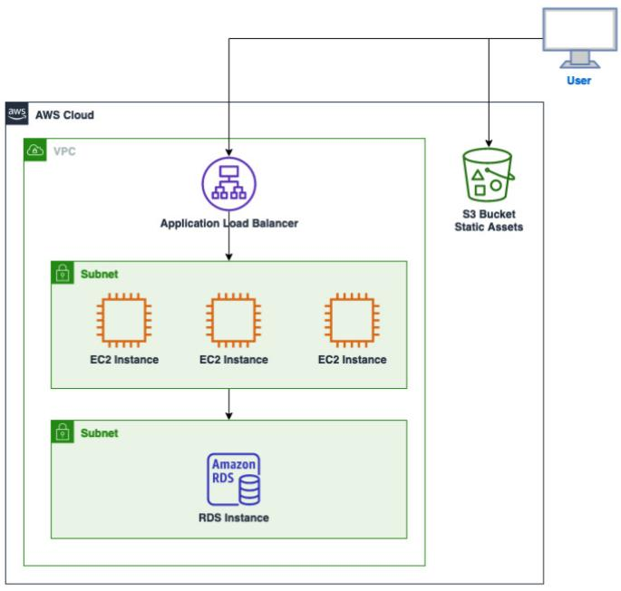
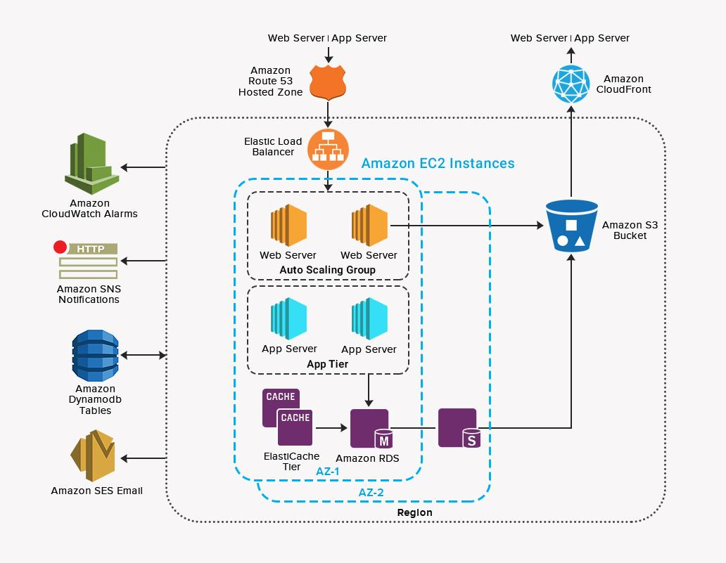
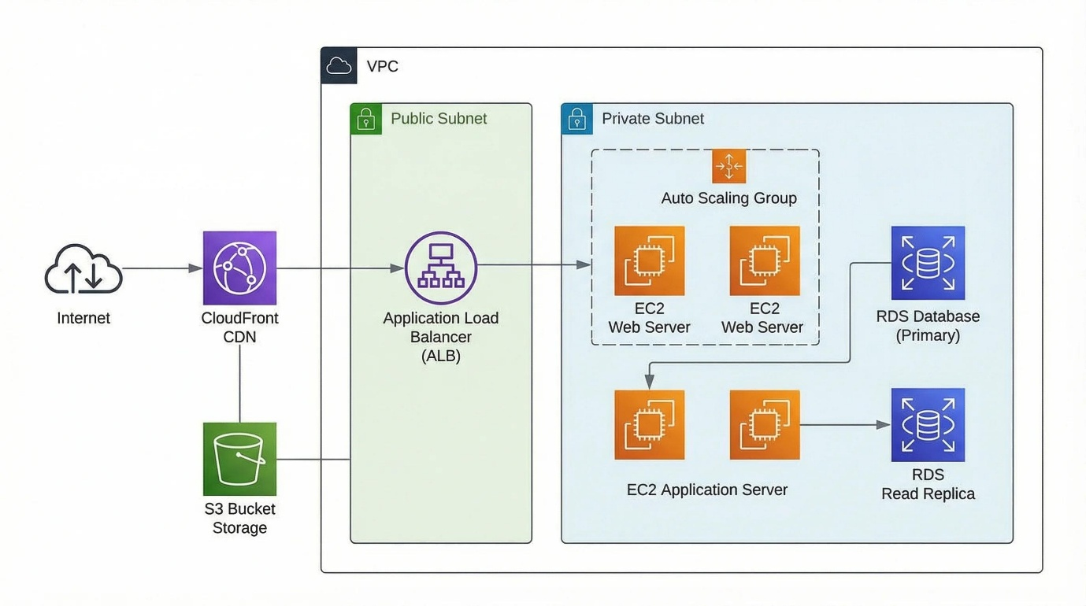
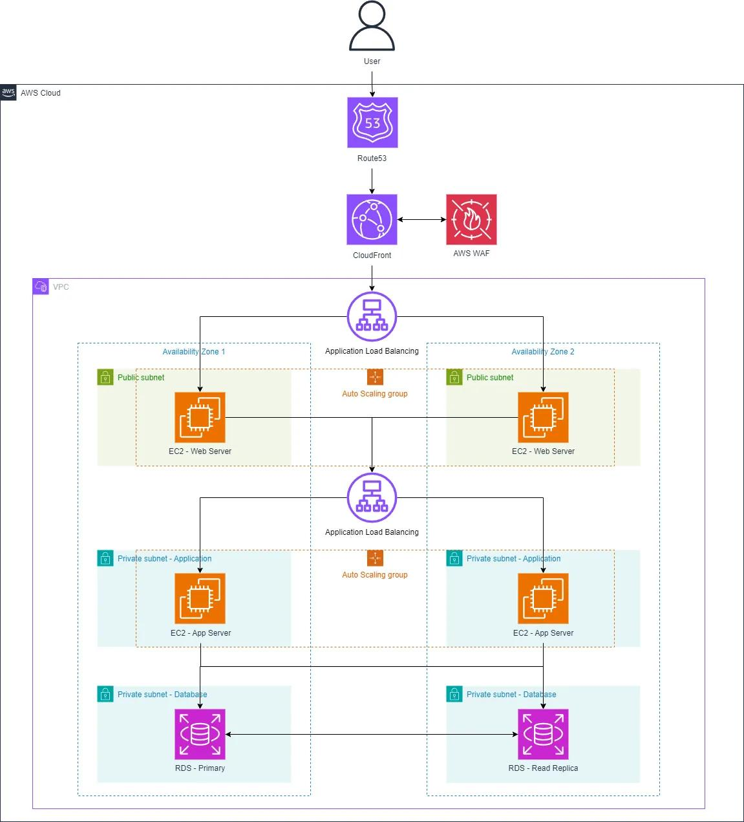
Components to label
- Users
- Application Load Balancer (ALB)
- App Server 1 — EC2
- App Server 2 — EC2
- Database — Amazon RDS
- Storage — Amazon S3
The ALB distributes requests between the two application servers. The application servers communicate with the database, while S3 stores images, posters, and other files.

3. Security measures
1. HTTPS
Use HTTPS/TLS for communication between users and the application. This encrypts data such as login information and booking details while they travel over the network.
2. Security Groups
Use AWS Security Groups to restrict network traffic. For example, only the load balancer can accept public web traffic, while the database accepts connections only from the application servers.
3. Authentication and access control
Use secure authentication and role-based access control so that only authorized users and services can access sensitive information.

4. 200–300 word document
You can submit the following:
Scalable Cloud Architecture for BookMyShow
I designed a scalable cloud architecture for a new BookMyShow feature called Real-time Ticket Availability. The feature allows users to view available seats and reserve tickets for movies and live events. Since popular events can attract thousands of users at the same time, the application needs an architecture that can handle sudden increases in traffic.
Users first connect to an Application Load Balancer (ALB). The load balancer distributes incoming requests between two application servers running on Amazon EC2. This prevents one server from receiving all the traffic and improves the availability of the application. If traffic suddenly increases, additional application servers can be added using an Auto Scaling Group.
The application servers communicate with an Amazon RDS database, which stores information such as users, movies, seats, and bookings. Important files such as movie posters and event images can be stored in Amazon S3, reducing the amount of storage required on the application servers.
During a major event or popular movie release, the number of users may suddenly increase. The load balancer distributes these requests across the available servers. Auto Scaling can monitor metrics such as CPU utilization and automatically launch additional EC2 instances when demand increases. When the event is over and traffic decreases, unnecessary instances can be removed, reducing resource usage.
Security Groups restrict network access between the components, while HTTPS protects user communication. Authentication and access controls protect user and booking information.
This architecture provides scalability, availability, security, and efficient resource usage while allowing the application to handle sudden traffic spikes.

5. Friend/family feedback
For this part, you need to actually ask someone. You shouldn't invent their response.
Ask them:
“Can you look at my cloud architecture and tell me one thing that is confusing or one question you have?”
Then put their actual response into this format:
Feedback/Question:
“Why do we need two application servers?”
My response:
“Two servers provide better availability and allow the load balancer to distribute traffic. If one server fails, the other can continue handling requests.”
If their actual question is different, use their exact question instead.

